**Identifying Goals and deliverables**

**Objectives:**

<https://www.youtube.com/watch?v=INHsqkkcjaM>

* Define and create project goals and deliverables.
* Define project scope, what’s considered in-scope, out-of-scope, and scope creep.
* Explain how to define and measure a project’s success criteria.

**Project that will be used throughout.**

You are the Lead project manager for office green.

Specialise in office décor and the CEO wants a new service for long-time customers called plant pals, offers high volume customers low maintenance fees.

Here we will see what my role is, what I will do and what my team will do from the life cycle of the project.

Having a clear goal and deliverable allows you to know what to work towards, how to work towards it and lead a team towards it.

Defining a clear goal

Is the desired outcome of the project.

Make sure the goal is as clearly and simply defined as possible, if it leaves room for inference then you won’t meet the goal or fill the requirements the stakeholders are looking for.

Make sure the goal is as clear and specific as possible.

Make sure tells you what you’re trying to achieve.

Make sure the goals tell you what to do and how to do it.

Clear goals are measurable and specific.

Like improve customer response time via email by 20%

Project Deliverables.

* The products or services that are created for the customer client, or project sponsor.
* What gets produced or presented at the end of a task, event, or process.
* Help quantify and realize the impact of the project.

Smart method

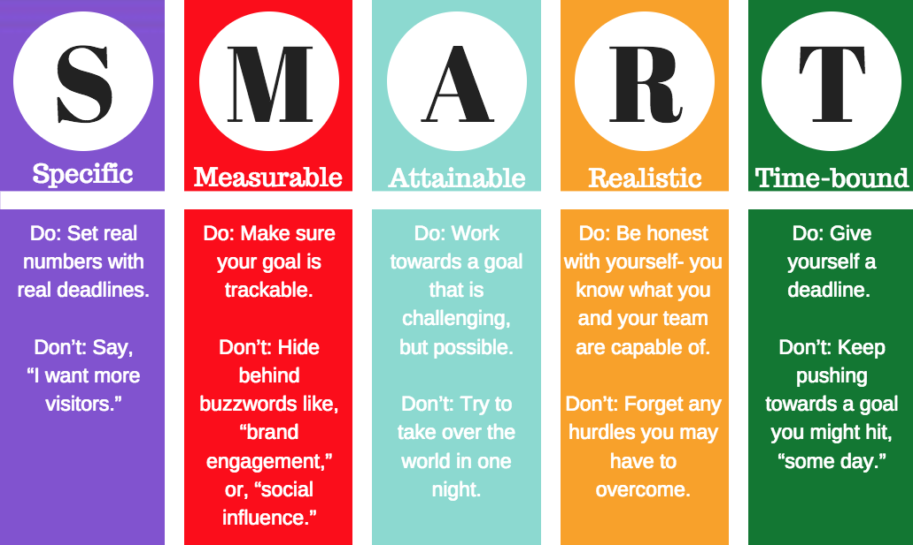

Used to define project goals (SMART)

OKR

Objectives + Key Results

**What ORK are**

They help establish goals and objectives

ORK combine a goal and a metric to determine a measurable outcome.

State clearly the goals and measure success of the goal

**Objective:**

* Define what needs to be achieved
* Describes a desired outcome by a number or metric

**Key Results:**

* The measurable outcomes that define when the objectives has been met

**How they are used**

Used in all levels of an organisation.

From a top level company ORK to debarment and team ORKs, they align and push for the success of their own ORK but also the company’s ORK.

They give a clear and ambitious goal and results that the company is aiming for.

**How they focus a team’s activity’s to success**

It allows a team to focus on what needs to happen or the goal their trying to achieve clearly which allows them to work towards it more clearly.

Project Scope. 3:04:02 <https://www.youtube.com/watch?v=INHsqkkcjaM&t=10673s>

**Project Scope**

Boundaries of a project, what is included and what is excluded.

It allows you to clearly define your project and mapped out, so you know what you’re working towards and what is included and what is not.

It includes all aspects of the project from:

* Timeline
* Budget
* Resources

Make sure to clearly define these so you know what boundaries you’re working in and how to achieve the desired end result.

Make sure at the beginning of the project you clearly define scope as this has a major impact to the success of the project, having a un-clear or bad scope will result in less success of a project.

To define scope or better understand It for a project have a clear communication with stakeholders , what their goals are and then defining it from their, like what is and isn’t included in your project.

Additional questions to ask to stakeholders when defining scope:

* Where did the project come from?
* Why is it needed?
* What is the project expected to achieve?
* What does the project sponsor have in mind?
* Who approves the finial results?

5W’s , who, what, where, why, how

Make sure defining project scope happens at the initial phase of the life cycle.

Make sure to properly document it through the life cycle.